Numerical Modelling using Monte Carlo method

Physics and equations used: -
To fix the Ideal Gas Law, physicists use the Virial Equation of State, which is a numerical model to account for real-world interactions.
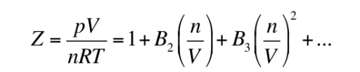

- Z is the "compressibility factor." If Z=1, the gas is ideal.
- The B terms are the correction factors for ideal gas law.
- B₂ (The Second Virial Coefficient) is the most important piece of the equation. It mathematically corrects for the energy changes that happen when exactly two molecules interact.
To find B₂ , we model how two molecules interact. We do this using the Lennard-Jones 6-12 Potential, a non-linear equation describing the "personal space" of a molecule:
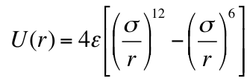

- $σ$ (Sigma): The physical size of the particle.
- $ε$ (Epsilon): The depth of the attractive energy well
To finally get our B₂ correction score, we must plug the Lennard-Jones potential U(r) into statistical mechanics to find the total volume of these interactions using the equation: -
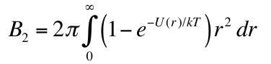

Since the Lennard-Jones potential U(r) is a complex fraction trapped inside an exponential function, this integral has no analytical solution. You cannot solve it with a pencil and paper.
How the problem was solved: -
To solve this math problem, I developed a a Python simulation using a technique called Direct Monte Carlo Integration. Instead of trying to solve the math equation normally, Monte Carlo uses randomness and probability to find the answer
My Python code does the Monte Carlo algorithms computationally.
- Draws a digital "bounding box" around our complex gas equation.
- Generates hundreds of thousands of random (x,y) coordinate "darts."
- Calculates the exact ratio of hits to misses.
- Uses that ratio to accurately output the final correction score, successfully bypassing the impossible calculus.

